The third part :Time attendance software user manual
1, Software features

- Use the same database with access control software
- Support 3 kinds of language, customers can add their own language as their will
- Simple operation, finishing operation by single click, double click, or right click.
- Directly use access control software’s records as time attendance records.
- No matter uses can enter or go out, we can take the logs once swiping the cards
- You can set the user to participate in time attendance or not.
- freely set many time schedules.
- There are 3 level depart. Management We can set different shits and rules for company, depart. and individual.
- Support inter-day card swiping, and free card swiping
- Support time attendance report calculating by day, hour, half an hour, and by minutes.
- support take morning, evening shift as working overtime, also support fixed working overtime..
- Support this working way of not swiping card between morning and afternoon and support night shift
- Support time attendance result’s editing
- Support time attendance result’s shift adjustment.
- Support asking for leave and business trip management
- Support color indicating to use different color to stand for different records, and
- Access；Support two database at the same time: MS Access and MS SQL server for option. The default is Access.
- System provide daily record, user can check the operation and management history record, easy to manage and system maintenance.
Providing data importing or exporting function, facilitating customers’ work processing.

2．Software installation
2.1After installing software， default user name and PW:

User name: admin
Password:
2.2 If users are more than 1000, we suggest that we use SQL server.

3, System requirement:
Operation system: Windows 98 or above like WIN XP, Winserver.
Database: MS Access and MS SQL Server
CPU: P2 800M
Storage: 256M
Display: 1024*876
For big system with more than 500 pcs of controllers, we suggest you use good CPU and big storage.

4．Basic operation procedures.

1, Install access control software
2, Run the software.
3, COM port management
4, Device---Add controller--Input serial no. or IP address and model no.
★5 Door parameters---Choose time attendance point

(Second) Time attendance operation procedure
1, Find “Time attendance” Firstly confirm you choose the device as time attendance point.
2, Set a work rest standard, add one shift’s days and work time zone.
3, Shift arrangement: set a work rest standard like office shift, and add this shift’s days and work time zone.
4, Set time attendance rules for one company, department.
5, Time attendance calculation: Choose one time scope to make calculation.
6, Time attendance interface to check calculation result.

1．Open access control software and set relevant access control operations. In device interface as below picture, double click the door icon we need select it as time attendance point. Then choose “Attend time attendance ”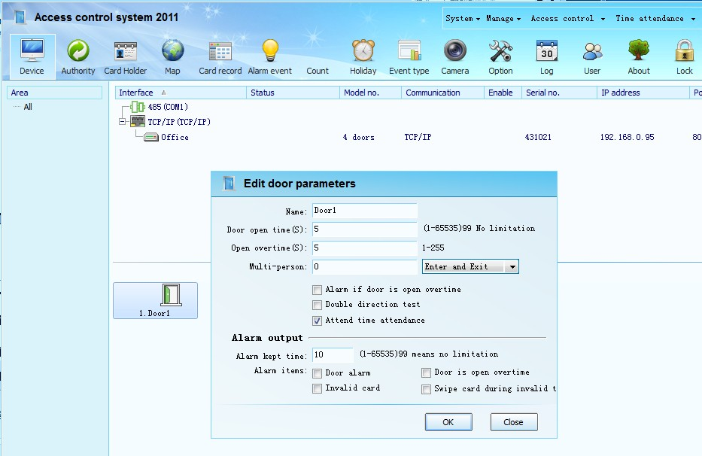

Then choose Time attendance menu and begin operation in the listed operations. 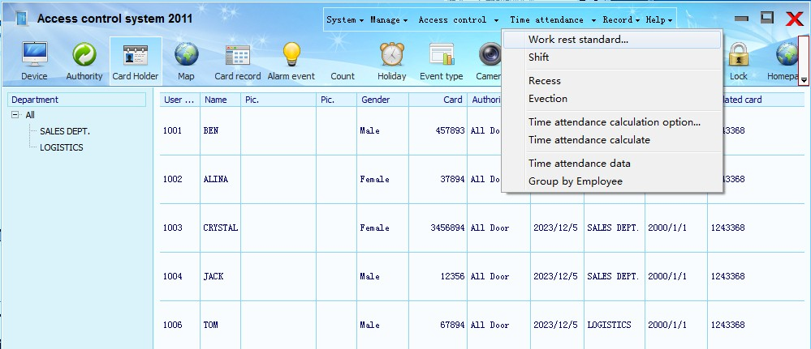

2. Work rest standard

Work rest standard is called shift,that is, we set work and rest days and time zone setting. Choose “Work rest standard”,Open it, and right click on blank area to add work rest standard.
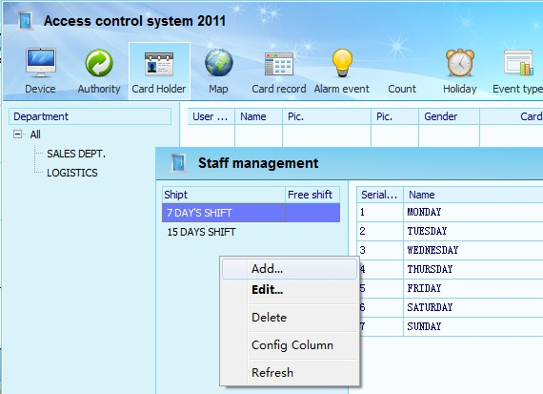

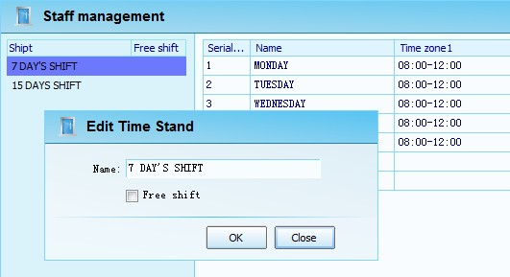

Input work rest standard name like: office shift, 3 shifts. We take office shift as example.
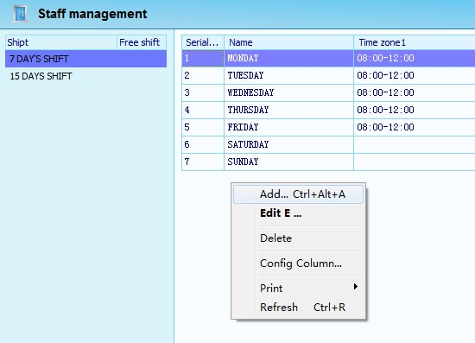

Choose the first day’s work rest time to edit. 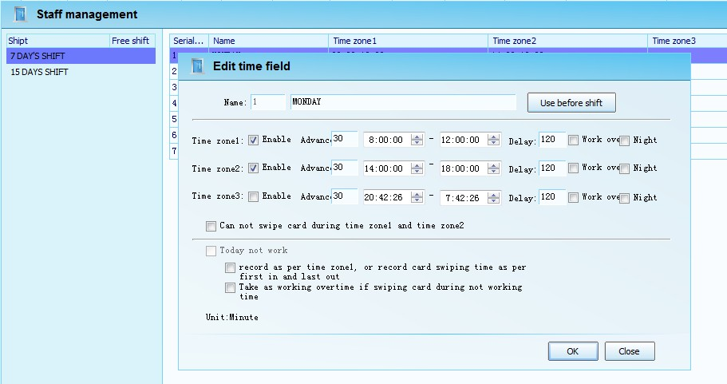

Input time name like Monday, The first day to ask us to remember easily.
Enable time zone, system make 3 time zone as per time attendance demand.
Advance: How many minutes stuff can swipe card in advance.If over this time, the records will not be calculated.
Delay: How many minutes stuff can delay card swiping. If over this time, the records will not be calculated.
Night: Means that this card wiping is at night. We can take this as working overtime from the below night time attendance strategy. After setting, press OK to store the setting

The same as the above operation, right-click on the blank o the dialog interface can increase the other schedules
Note: schedules days must be determined by the cycle of the work time, including rest time, such as administrative class, which is suitable for work time from Monday to Friday, Saturday and Sunday to rest time, regular cycle is seven days, so the schedule time we should set up to seven days, just Saturday and Sunday is not enabled.As follows.
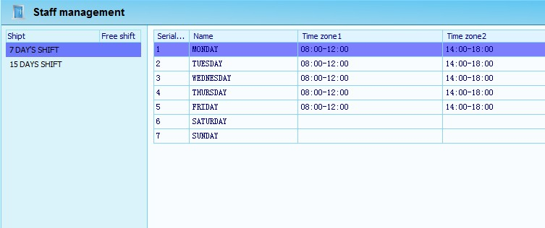

Work-rest standard is to have the summarize and set on the work and rest time . The rest time can’t be omitted.
If set three shifts work and rest standard, it may 21 days be one circulation,so you should set up for 21 days of work and rest time.
If set big and small weeks such as work and rest standard, it may15 days be one circulation ,so you should set up 15 days of work and rest time.
What kind of work and rest standard and work and rest days, finally according to the actual need to determine.
3. Time attendace system
Attendance system is set up in what time zone to perform what work and rest standard, can for the company, department, group and individual set up separately.General for the entire company need to set up one time attendace system,if some departments or personnel attendance system is different from the company, may need to set up separately for these departments and personnel.
Choose time attendance drop-down menu - attendance scheduling, open the scheduling dialog
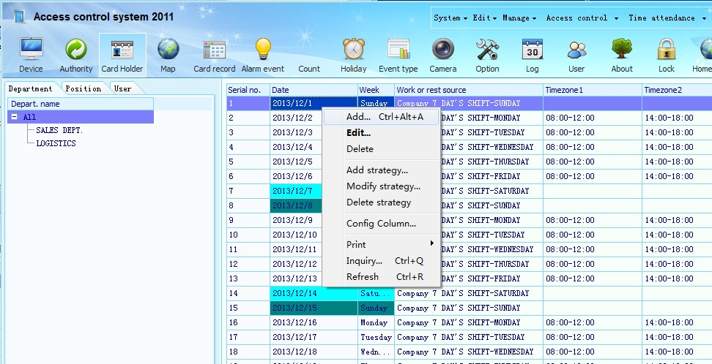
Chose all of the left ,and on the right of will automatically arrange the schedule of work and rest time samples in 30 days, right-clicking on schedules, choose to increase
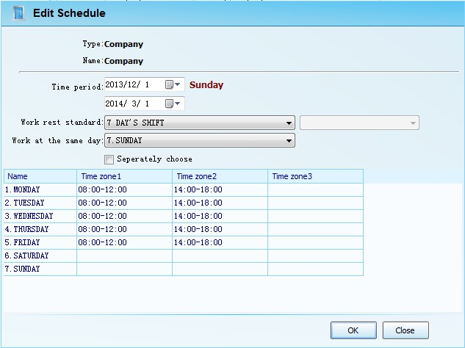

Set up the work and rest time attendace system to the company object: note to properly set the date range (start time and end time), select work and rest standard and on the day of work..The day on work is what’s the work and rest on that day time on the start date in the date range ,such as the above 2013/12/1 this day is Sunday, the day to work in the administrative class time should choose seventh day in administrative class, which is on Sunday, as shown above.
After setting up, point the OK to save the setting..

4. Time attendance strategy
Attendance strategy is how to come to work, how to assessment the staff attendance.Such as how many minutes late is late, how much time is absenteeism, etc.Must be set at least one strategy for the whole company, if some departments or people with different from company, you have to separate set to these departments and people.
Select all in attendance scheduling dialog box on the left, then right click again on the right interface schedules point, choose to add strategy, open the attendance strategy edit box
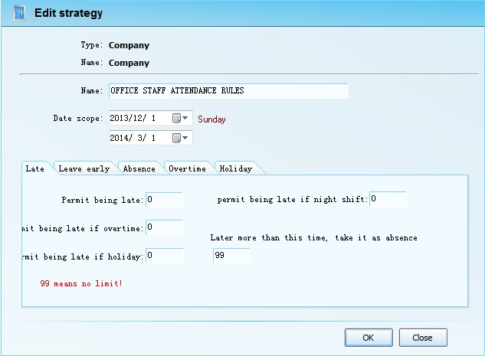

Set the strategy execution time range (start time and end time), fill in the assessment method of late, leave early, absenteeism, work overtime, holidays, point OK to complete.
5．Work attendance calculation
After setting the work and rest standard, the work attendance system, attendance strategy, and then set up the calculation of some parameters, can proceed to the calculation and analysis of check on work attendance.
Setting the calculation options before calculation .
Choose attendance drop-down menu – attendance calculation options dialog
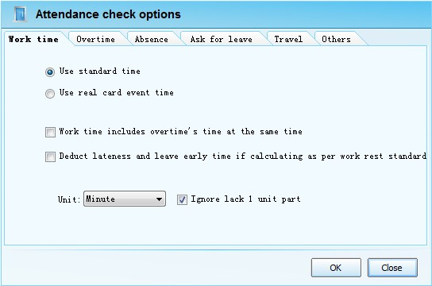
Setting calculation unit, such as calculation conditions, point OK to complete modification.No modification can have no operating.
Choose attendance drop-down menu – time attendance check
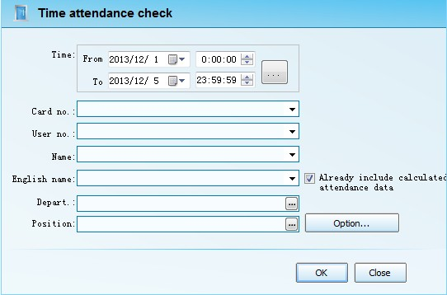
Select the attendance calculation range: time range, department, card number, name, etc to have the Filtering calculation

Calculation process:
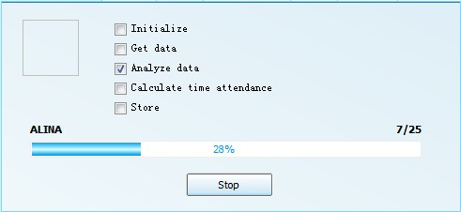

6．Work attendance result
Attendance is evaluated, you can view the report data, also can undertake the report output.

Attendance data:Choose attendance drop-down menu - attendance data
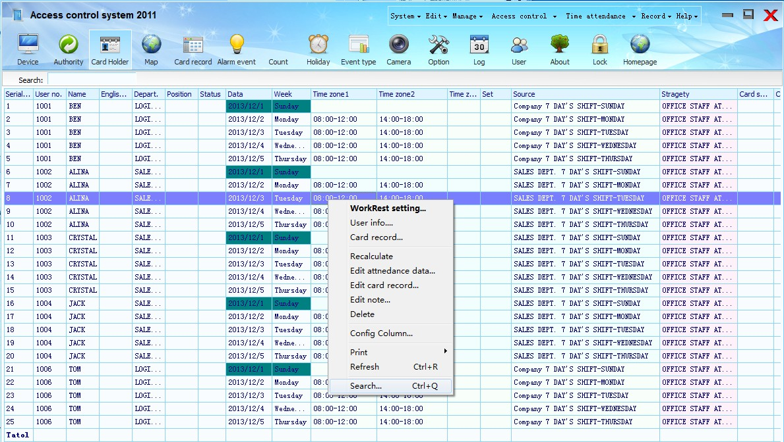
Right-clicking on the data table can edit and inquiry the attendance data.
Modify the card record :the actual card record can be modified.
Adjust the schedule :if the day's work-rest standard is not correct, can be adjusted freely here
Recalculate: if you modify the card record or modify the attendance settings, can have one new recount for this rows .
Modify the attendance records : can modify the results of work attendance, such as late, leave early, working hours and other specific data.
Inquiry : can set the filter conditions to inquiry attendance data, and can export the data you inquired.The exported data is the same with the inquired data, namely, what you see is what you get.
Choose attendance drop-down menu, staff attendance statistics
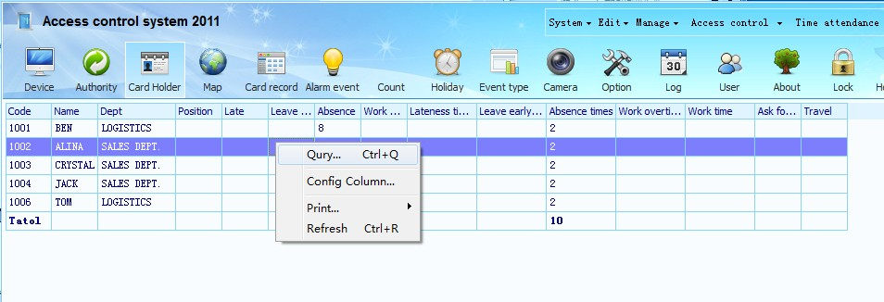
According to a person ,a department, or a job to have the filter statistics, inquiry results, exporting the report.
Import the reoprt :right-click on the inquired attendance record , choose print - select import format - named - save


